
Student Name: Faith Wanja Gichure
Admission Number: BSCCS/2024/31978
Unit Code: BIT4133
Unit Name: Natural Language Processing with Deep Learning
NLP Extra Work
NLP Project Title: SMS Spam Detection System
Technologies Used: Python, NLTK, Scikit-learn, Google Colab, Pandas, Matplotlib
GitHub Link: https://github.com/faith-dev122/BIT4133-NLP-Project

Table of Contents
EXTRA WORK SECTION 1 3
Fig 1- Stemming Output (Porter Stemmer) 4
Fig 2- Stemming Output (Snowball Stemmer) 5
Fig 3- Lemmatization 5
Fig 4- Stemming vs Lemmatization comparison 5
SUMMARY 6
EXTRAWORK SECTION 2 7
Fig 1- Basic word frequency counter 7
Fig 2- Word frequency bar chart 8
Fig 3- Word frequency bar chart 8
Fig 4-Comparing spam vs ham word frequencies 9
SUMMARY 9
EXTRAWORK SECTION 3 10
Fig 1- Syntax Sentence Structure Analysis 10
Fig 2- Semantics dealing with the meaning of words and sentences 11
Fig 3-Fragmantics understanding intended meaning from context 12
Fig 4- Combination and comparison of syntax, semantics and Fragmatics 12
SUMMARY 12
EXTRAWORK SECTION 4 13
Fig 1- Syntactic Parsing Chunking Extracting Noun Phrases (NP) and Verb Phrases (VP) 13
Fig 2- Dependency-Style Analysis understanding which words depend on which 14
Fig 3- Semantic Similarity how similar are two sentences in meaning 14
SUMMARY 14

EXTRA WORK SECTION 1

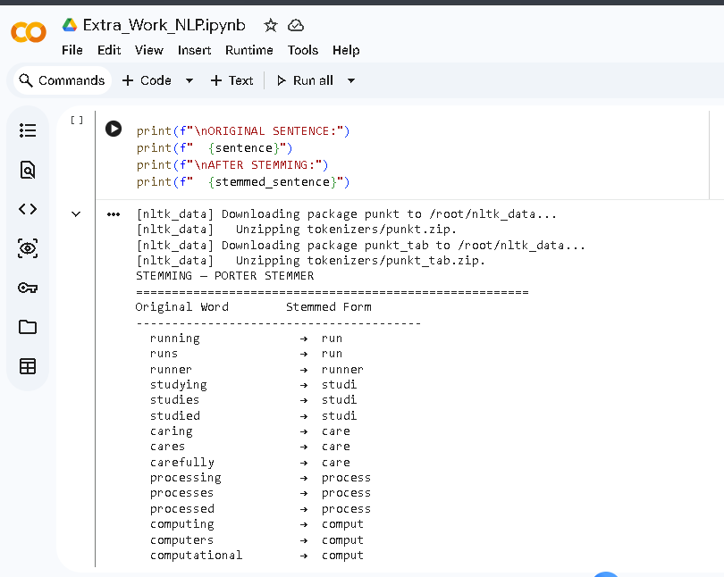

Fig 1- Stemming Output (Porter Stemmer)


Fig 2- Stemming Output (Snowball Stemmer)
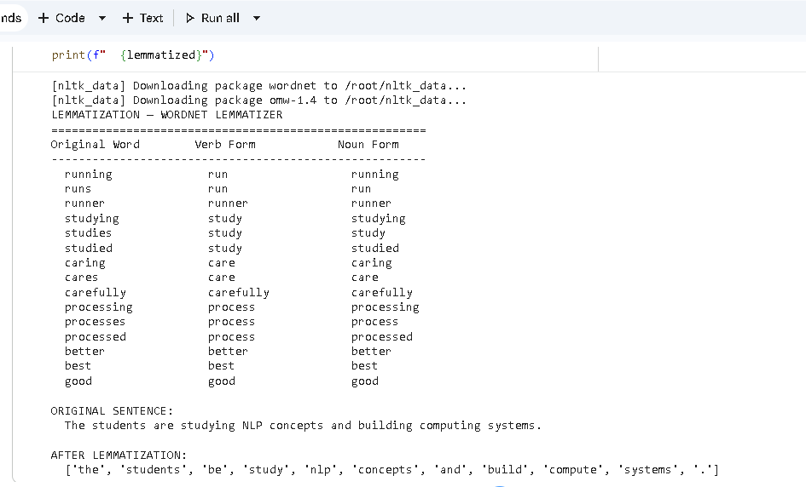

Fig 3- Lemmatization
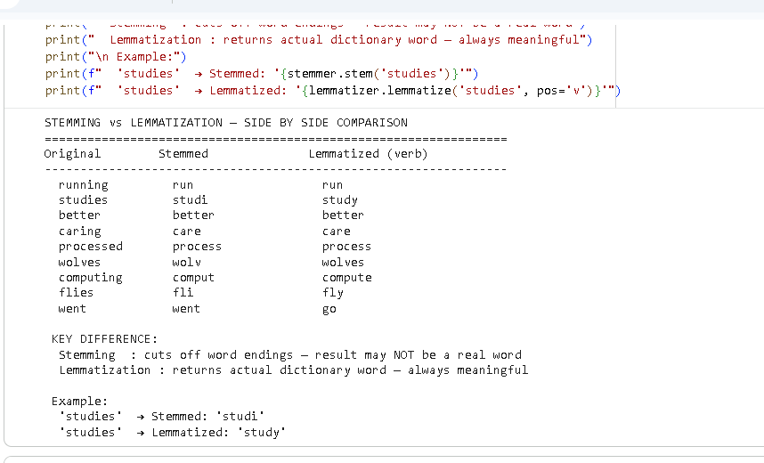

Fig 4- Stemming vs Lemmatization comparison

SUMMARY
Stemming in Fig 1 and Fig 2 both removes suffixes from words to form a stem, for example the word running is reduced to the word run by both the Porter and Snowball stemming algorithms. Lemmatization (using the WordNet Lemmatizer) returns appropriate dictionary forms such as 'studies' to 'study', and ‘better' to ‘good'. (See Fig 3) The two techniques are compared in Fig 4. The difference is that stemming can generate non-real words, such as 'studi' while lemmatization always generates a real word. Lemmatizing is more accurate but slower, stemming is faster but less accurate. Both of them are crucial steps in our SMS Spam Classifier Pipeline that are performed prior to the processing.

EXTRAWORK SECTION 2
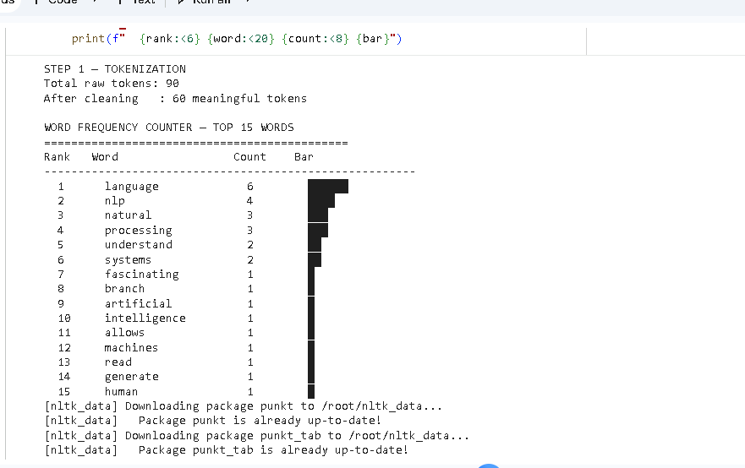

Fig 1- Basic word frequency counter

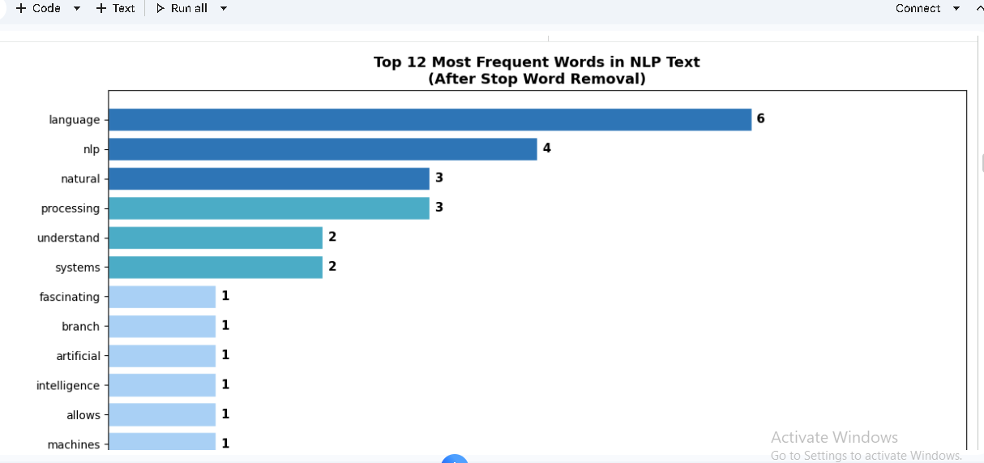

Fig 2- Word frequency bar chart
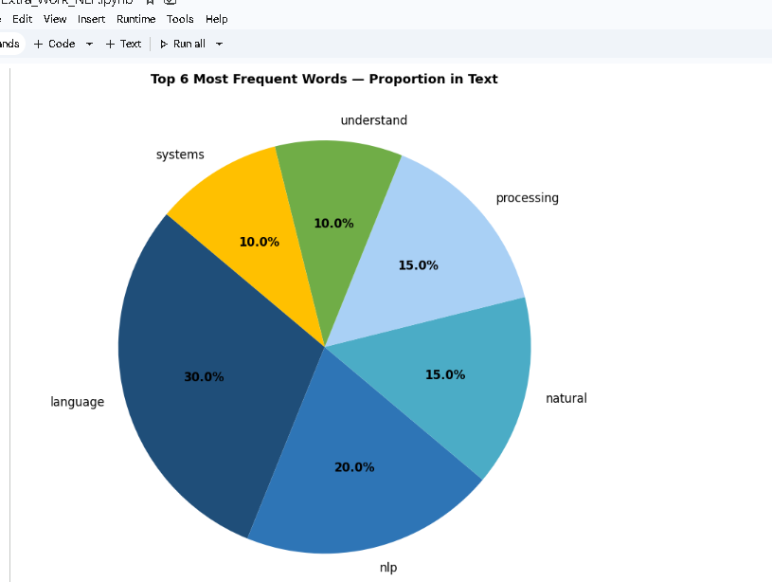

Fig 3- Word frequency bar chart
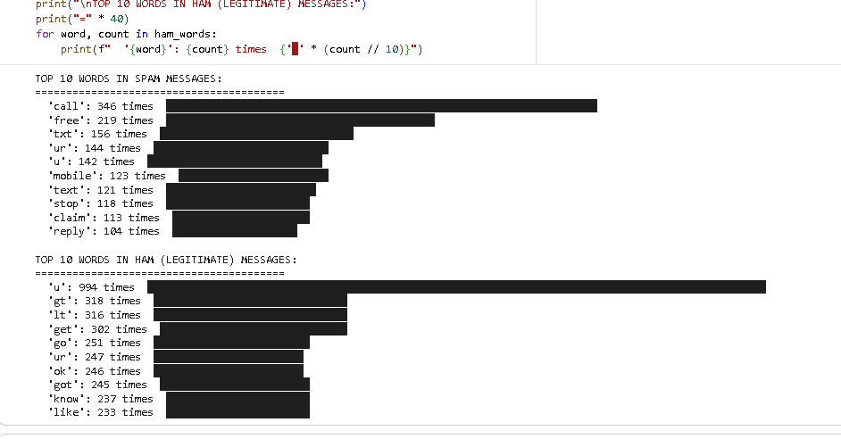

Fig 4-Comparing spam vs ham word frequencies

SUMMARY
After tokenization and stop word removal, the most frequent words in the paragraph of the NLP text given in Fig 1 are highly concentrated on the central topics of the text, namely ‘nlp’, ‘language’, ‘processing’, and ‘learning’. The top 12 words are represented graphically in a horizontal bar chart (Fig 2) and as a pie chart (Fig 3) representing the proportions. With our own SMS Spam dataset, the word frequency analysis is shown in Fig 4 where words such as ‘free’, ‘call’ and ‘txt' are frequently used in spam messages while conversational words are more often used in ham messages. The basis of TF-IDF is word frequency analysis that is used in our spam classifier.

EXTRAWORK SECTION 3
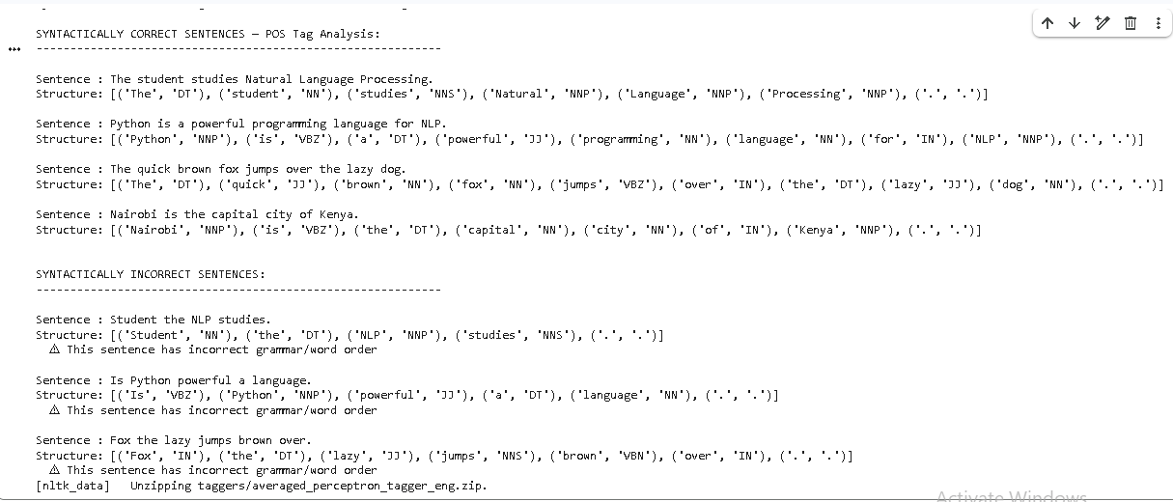

Fig 1- Syntax Sentence Structure Analysis

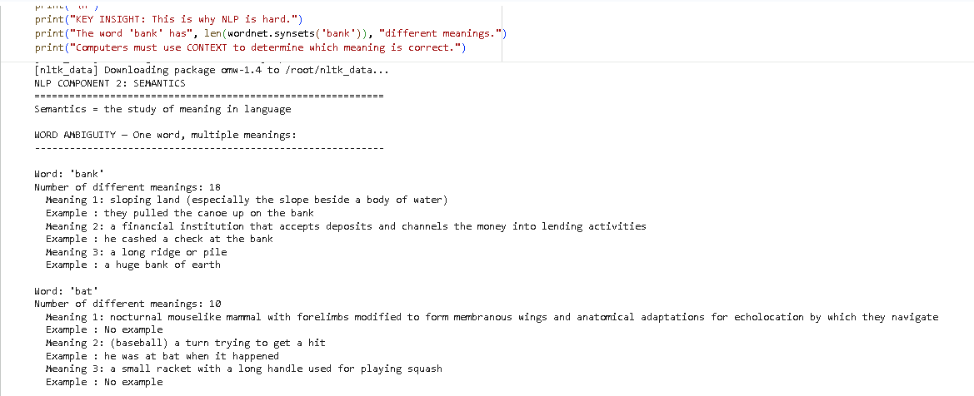

Fig 2- Semantics dealing with the meaning of words and sentences
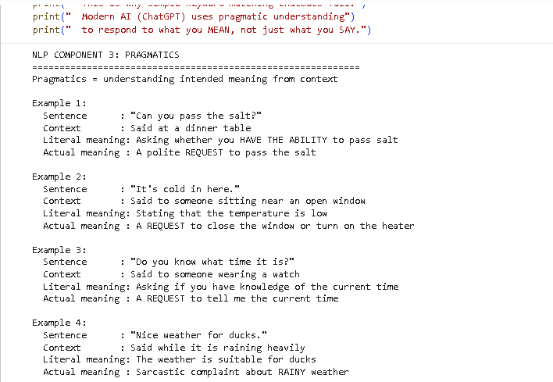

Fig 3-Fragmantics understanding intended meaning from context
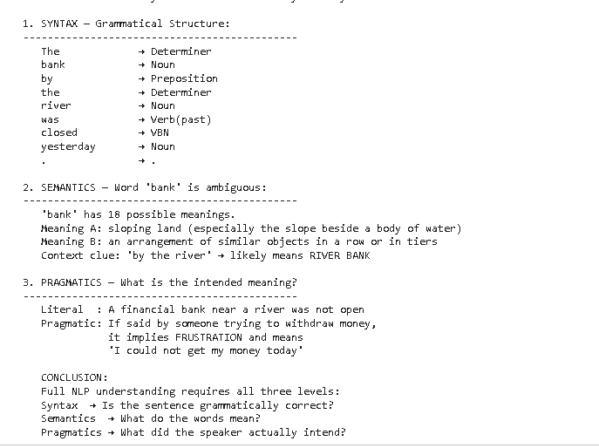

Fig 4- Combination and comparison of syntax, semantics and Fragmatics

SUMMARY
Fig 1: syntax analysis, Fig 2: POS tagging, the grammatical structure of correct sentences vs scrambled incorrect sentences. The semantics of Fig 2 is illustrated by the fact that the term bank has different meanings in the computer world, and that computer programs must use their context to choose the appropriate meaning, which is the most difficult aspect of semantic analysis. In Fig. 3 pragmatics are explained by using real examples and revealing the difference between what is actually said and what is actually meant. Fig 4 takes all three parts and applies them to one sentence. The ability of modern AI chatbots like ChatGPT to engage in intelligent conversations is a result of comprehending the syntax, semantics, and pragmatics.

EXTRAWORK SECTION 4
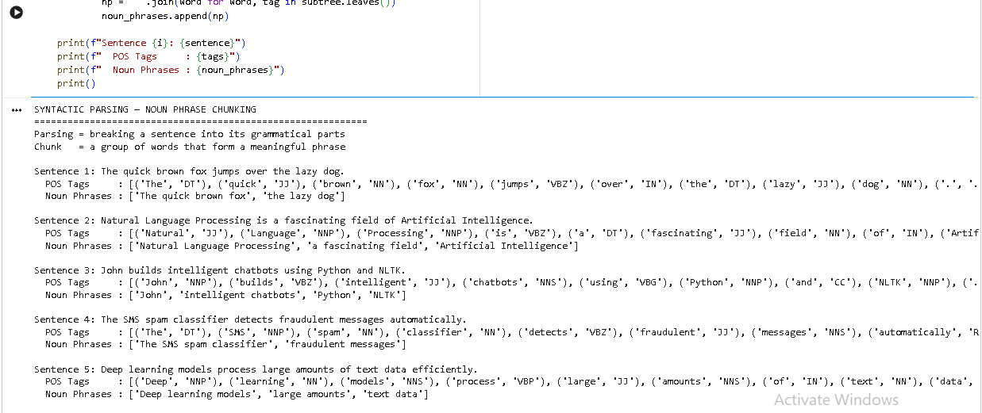

Fig 1- Syntactic Parsing Chunking Extracting Noun Phrases (NP) and Verb Phrases (VP)

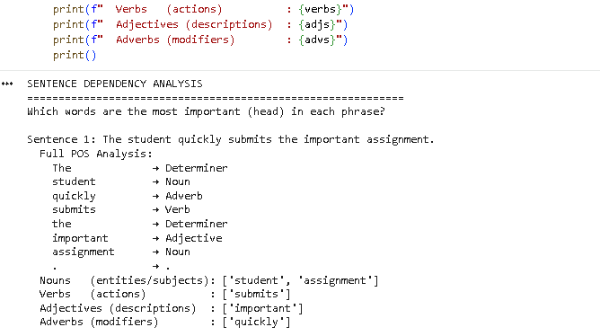

Fig 2- Dependency-Style Analysis understanding which words depend on which
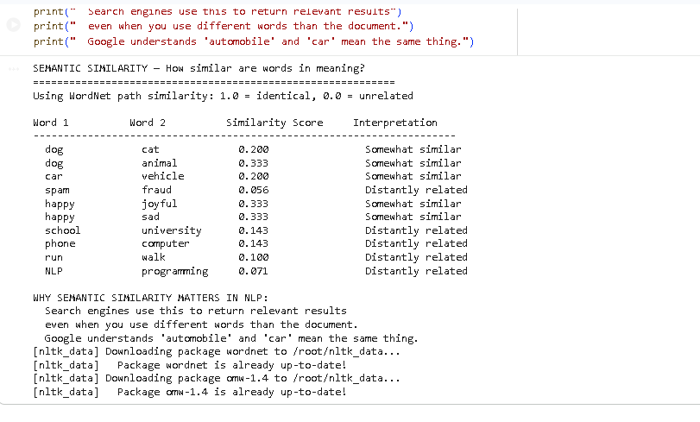

Fig 3- Semantic Similarity how similar are two sentences in meaning

SUMMARY
The parser worked well in identifying noun phrases in sentences 5 from the text, as shown in Fig 1, by following the grammar rules on the POS tagged tokens. The dependency analysis is conducted on each sentence, separating the nouns, verbs, adjectives and adverbs, as shown in Fig 2, which helps to understand the structure of each sentence. Fig 3 shows semantic similarity as WordNet path similarity score: dog' and 'animal' had a high score while 'happy' and 'sad' had low score. This proves that meaning of words could be measured mathematically by computer. In machine translation and grammar checkers, syntactic parsing is used, and in search engines and recommendation systems, semantic similarity is used.

